**Experiment 3**

**Student Name: Yash Gupta UID: 20BCS5009**

**Branch: BE-CSE Section/Group: 20BCS-MM-806 A**

**Semester: 5 Date of Performance: 26-08-2022**

**Subject Name: MMT LAB Subject Code:**

**AIM:** - Procedure to type a word and apply the effects shadow emboss using Photopea.

**Hardware Requirements: -** Minimum 384MB RAM, 100 GB hard Disk, processor with 2.1 MHz

**Software Requirements: -** Photopea

**Tools Used: -** Type Tool, Bevel and Emboss, Emboss option.

**Step 1:**  Create the new project and set the dimensions according to the requirement.

**Step 2: Select text button and type any word.**

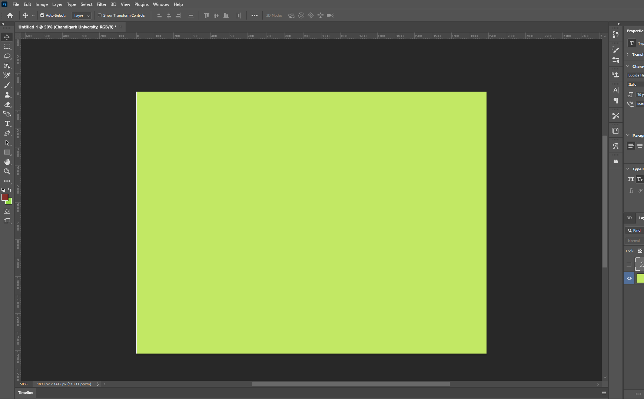

**Step 3: Select font type.**

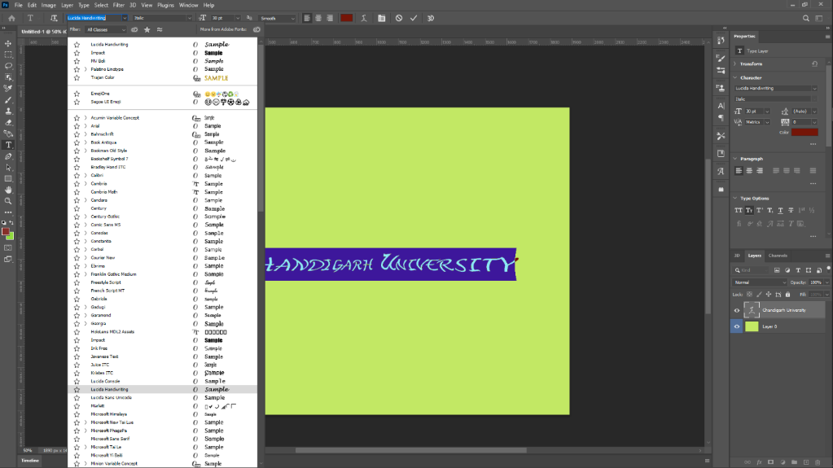

**Step 4: Select Bevel and Emboss option.**

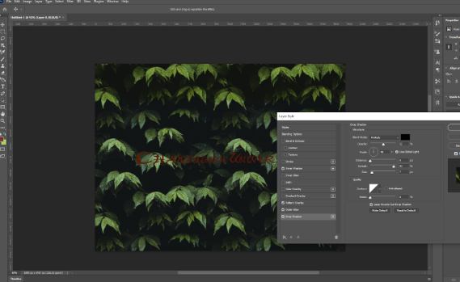

**Step 5: Select emboss option according to requirements.**

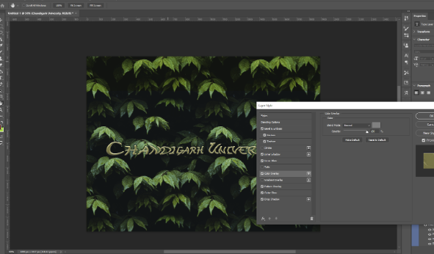

**Evaluation Grid (To be created as per the SOP and Assessment guidelines by the faculty):**

|  |  |  |  |
| --- | --- | --- | --- |
| Sr. No. | Parameters | Marks Obtained | Maximum Marks |
| 1. |  |  |  |
| 2. |  |  |  |
| 3. |  |  |  |
|  |  |  |  |